Question A: Individuals seen at large city Sexually Transmitted Disease (STD) Clinic are considered at a high risk for acquiring the HIV virus. The following data is recorded on 100 high-risk individuals who are infected with some STD, but did not have the HIV virus, when they were seen at the clinic in 1980. Their records were checked at subsequent visits to determine when the HIV virus was first detected.

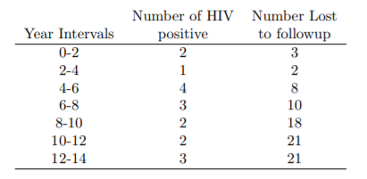

1. What kind of study design is this, a cohort or case-control?

This is a cohort study for the incidence of HIV virus

2. What are the start time and end time for this study? Do you feel that this time scale is appropriate?

The start time is 1980, the first time they were seen at the clinic. The end time is 14 year later.   
The time scale is years since 1980.   
This is appropriate since one question of interest is the rate of new infections in the population. 1980 was the earliest that the disease was detected.

3. What is the event for this study?

The event is an infection with the HIV virus. People may have the event during the study (observation) period.

4. Are the data subject to censoring?

Yes, these people are censored.

5. Why might the censoring not satisfy the assumption of independence?

One possibility is that the person dies from a related cause to HIV. Namely when a person with HIV develop AIDS the person is at higher risk of dying from another cause.

EX 6. What kind of statistical tests you might use?

The log-rank test and Gehan-Breslow-Wilcoxon, or reasonable answers.

# Question B:

1. What is meant by the term “median survival”?

The length of time (from time origin), that half of the instances in a population have experienced an event.

2. TRUE or FALSE: When it comes to the independent censoring assumption, using fixed right censoring it is typically safe.

3. Describe why it is necessary to require censoring for many studies.

An individual withdraws from the study   
Individual moves away or is lost to follow up (stops participating in study)  
Because they did not have the event while you are observing them, doesn’t mean they will not develop it later, But this information does not have an effect on your study

4. Which of the following statements are true about survival analysis? ABCD

A. Survival analysis has a dichotomous (binary) outcome  
B. Survival analysis analyzes the time to an event  
C. Kaplan-Meier curves applied in survival analysis  
D. Cox proportional hazards models are used in interpreting results.